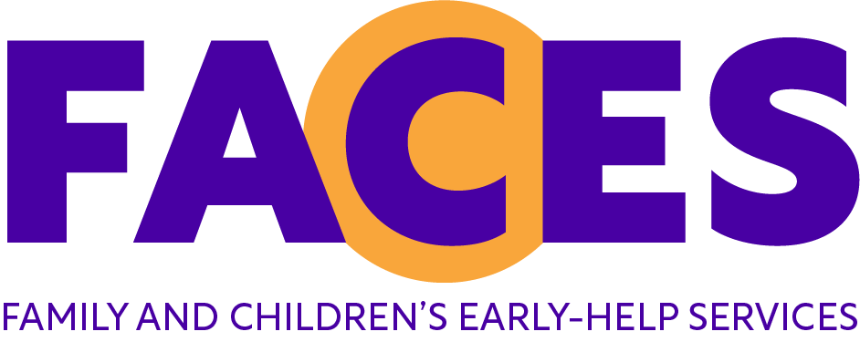

Application Form for Volunteers
FACES Bedford (Family and Children’s Early-help Services)

Confidential
If you have difficulty completing this form, you are welcome to ask any member of the FACES team for assistance.

Name
Address including postcode

If you have been at this address less than five years, please give previous address
Home telephone no: |  | Mobile telephone no.:
Email address:
Date of birth: |  | Place of birth:
Emergency contact name and phone no:

We do not charge volunteers to enrol on our volunteer training course. However as a result of rising costs we do require a £30 returnable deposit to secure your place on the course which covers course materials and completion of your DBS check (formerly CRB check). This deposit will be returned to you when you have been linked with your first family.

Are you willing/able to provide a £30 deposit? Yes/No. If no, please call us to discuss.
REFERENCES: Please give the name and address of two referees that you have known for a minimum of two years (not a relative or member of your household). Include at least one professional reference (most recent employer wherever possible; alternatively, school, college or other professional such as a religious leader or a volunteer supervisor) who may be contacted by FACES.
Please ask permission prior to submitting referees details and confirm full address.
CURRENT OR MOST RECENT EMPLOYER WHERE POSSIBLE  Referee 1 – Professional reference  How long have you known this person  In what capacity? |  | Referee 2 – Personal reference  How long have you known this person  In what capacity?
Name:  Address:  Postcode:  Email:  Telephone: |  | Name:  Address:  Postcode:  Email:  Telephone:

Monitoring Information

Asian or Asian British |  |  | Black or Black British |  |  | White
Indian |  |  | Caribbean |  |  | British
Pakistani |  |  | African |  |  | Irish
Bangladeshi |  |  | Any other Black background Please specify |  |  | Any other white background Please specify
Any other Asian background Please specify
Chinese or other ethnic group |  |  |  | Mixed
Chinese |  |  | Any mixed background Please specify __________________________
Other
Sex
Male
Female
Transgender

We would like to get a picture of your experience to date. In the first box please give us details of any paid employment, in the second box details of any voluntary or unpaid work and in the third box details of gaps in employment with reasons e.g. career break to look after children or other dependants, travelling, training or education. Please continue on a separate sheet if necessary.

*Please note we cannot accept a CV in place of completion of the sections on employment below*

Please tell us about any paid employment, starting with most recent

Continue on a separate sheet if necessary.
Employer | Job title | From | To | Brief description of duties | Reason for leaving

Please tell us about any voluntary or unpaid work, starting with most recent

Employer | Job title | From | To | Brief description of duties | Reason for leaving

Please tell us about gaps in your employment history, starting with the most recent

From | To | Reason

Do you speak any additional languages (including sign language)
What is the maximum time you could offer to FACES as a volunteer on a regular weekly basis (our minimum requirement is 2 to 3 hours per week)?
Have you any commitments which could affect your work with FACES e.g. part-time work, caring responsibilities, course of study etc?
What type of transport do you use? |  | If you use a car, do you hold a current and clean driving licence?  Yes/No  Date of expiry:
1) Please give information about your own parenting experience: e.g. are you a
Parent/step-parent/foster carer? Please give ages of children

2) What did/do you find enjoyable about parenting?

3) What did/do you find challenging?

4) If you are not a parent, please tell us about any experience you have had working with children and in what capacity.

What are your hobbies and leisure interests?

How did you hear of FACES?

Why would you like to become a FACES volunteer?

Have you any skills or personal experiences which may be relevant to your work as a volunteer for FACES?

Is there any other information you would like to add?

As volunteers are in a privileged position visiting families in their own homes and have contact with young children, FACES has a responsibility to ensure that no one becomes a volunteer who would misuse this trust. Therefore, it is essential that you complete and sign this form.

For more information please visit:
www.gov.uk/government/publications/dbs-application-forms-guide-for-applicants

Name:
Have you had any personal contact with Social Services/Social Work Department or NSPCC in connection with children in your care? Have any of your children been subject to a child protection, child in need plan or early help assessment (EHA)? | Yes/No
Do you consider yourself to have a disability or health condition and if so what adjustments could FACES provide to enable you to volunteer?  Please provide detail, continue on separate sheet if required. | Yes/No
Have you ever been dismissed from any paid or voluntary work? | Yes/No
Have you ever been arrested or had contact with the police for any type of criminal offence? | Yes/No
Are there any matters outstanding which may lead to a criminal prosecution? | Yes/No
If you answer yes to any question please give details:

If you do not declare existing or spent cautions or convictions you may not be selected. However, if you declare any of the above, in some circumstances, it may still be possible to become a volunteer.
I know of no reason why I would be unsuitable to be a FACES volunteer.  I will report any changes in my circumstances which may affect my role* | Agree/Disagree
*child/ren in care/criminal proceedings brought against me etc
- I give permission for FACES to carry out criminal record checks (DBS) at enhanced level with the appropriate agency.
- I understand that my National Insurance number, passport and/or drivers licence may be required for identification purposes.
- I understand that FACES may hold personal information about me in paper records and on their computer, including sensitive information such as age, race, sex and disabilities that they will use for their monitoring purposes. I agree to them holding this information. I understand that I may ask to see my records at any time.

Signed: Date:

As you will be completing an Enhanced Disclosure form detail of any criminal convictions or cautions found will be passed onto to FACES. Therefore it is important that you highlight any issue we need to be aware of on your application form.

If something is highlighted on your disclosure this will be discussed with you in confidence. Following the meeting a decision will be made whether we can proceed with your application. If you have any concerns please discuss this further with the FACES Operational Practitioner

Rehabilitation of Offenders Act
This post is exempt from the provisions of the Rehabilitation of Offenders Act, 1974. You must therefore disclose any criminal convictions, including spent convictions, suspended sentences and bind over orders (delete as appropriate)
Have you ever been convicted of a criminal offence?  If yes you may be asked to supply details. | YES | NO
This post is subject to criminal record checks”DBS” at enhanced level.

Declaration
I declare that to the best of my knowledge and belief, all statements contained in this form are correct. I understand that should I make a deliberate misrepresentation any volunteering opportunities offered to me may be terminated. In submitting this information I agree that my application details may be held securely by FACES

Signed:
Date:

For Office use only

Date application received
Application is signed and dated | YES | NO
IF NOT SIGNED INSERT DATE RETURNED TO APPLICANT

s

